IoT Based Intelligent Agriculture Field Monitoring System

Md Ashifuddin Mondal

Department of Computer Science and Engineering Narula Institute of Technology

***Abstract*— Agriculture is becoming an important growing sector throughout the world due to increasing population. Major challenge in agriculture sector is to improve farm productivity and quality of farming without continuous manual monitoring to meet the rapidly growing demand for food. Apart from increasing population, the climate change is also a big concern in agricultural sector. The purpose of this research work is to propose a smart farming method based on Internet of Things (IoT) to deal with the adverse situations. The smart farming can be adopted which offer high precision crop control, collection of useful data and automated farming technique. This work presents an intelligent agriculture field monitoring system which monitors soil humidity and temperature. After processing the sensed data it takes necessary action based on these values without human intervention. Here temperature and moisture of the soil are measured and these sensed values are stored in ThingSpeak [11] cloud for future data analysis.**

**Keywords—Internet of Things, Smart Farming, Agriculture, ThingSpeak cloud.**

1. INTRODUCTION

According to Beecham's report entitled “Towards Smart Farming: Agriculture Embracing the IoT Vision” predicts that food production must have to increase by 70 percent in the year 2050 in order to meet our estimated world population of

9.6 billion people [9]. Hence, it is very important to boost up the agricultural productivity to ensure high yield and farm profitability. The major challenge in quality farming is unpredictable weather and environmental conditions such as rainfall, temperature, soil moisture etc. Moreover, humidity is one of the major environmental parameter in farming as it affects the turgor pressure of plants, which is an indicator of the amount of water in plant cells. When the amount of humidity in air is low, transpiration takes place very quickly in plants. Further, due to high rate of transpiration, plants wilt rapidly as too much water is pulled out from plant cells. On the contrary, when amount of moisture in air as well as temperature is high, the rate of transpiration is reduced which in turn restricts evaporative cooling. In order to monitor these environmental conditions and action have been taken accordingly, continuous manual effort was required which is quite impractical and not possible all the times.

In this respect, IoT plays a significant role in implementing the concept of smart farming to automate the farming operations.

IoT is new computing and communication paradigm in which the objects of everyday life have equipped with sensor, microcontroller and transceiver to sense the surrounding environmental parameters. In addition, communication of the sensed data with one another or user, becoming an integral part of Internet system. In IoT, every objects used in our daily life with unique identifier is connected with each other so that they can send data over the network without human intervention [1, 2]. IoT is growing day by day as many more objects are going to be connected throughout the world. IoT can be used in many different domains such as precision agriculture [1, 2], Smart grid [3], environmental monitoring

[4] etc. IoT technology is gaining popularity in agricultural field for its highly scalable, interoperable and pervasive nature.

To automate the farming operations, several environmental parameters those have impact on farming, are required to track down at different locations. The important environmental parameters include temperature, moisture, and water level. Different types of sensors are deployed over the field to monitor those environmental parameters related to farming and attached with microcontroller. According to environmental condition, microcontroller controls different actuators or farming equipment (Pump, Fan etc.) without human intervention. Apart from that these sensed data can be stored in the cloud. Microcontroller attached with wi-fi module sends those sensed parameters to the cloud. Most wireless environment monitoring system uses GSM based and or CDMA/GPRS technology. But they have several disadvantages including high cost of network forming, low access rate etc. To be the part of internet, the objects have unique identifier. Internet Protocol version 6 (IPv6), Internet Protocol version 4 (IPv4) is generally used as a unique identifier of the objects.

The rest of the paper is organized as follows. Section II highlights related work on smart farming. Section III describes the proposed system design for IoT based smart farming. Section IV presents the experimental setup for implementing the proposed system and results. Finally, Section V concludes the paper.

# 625

1. RELATED WORK

In [5], M. A. Abdurrahman, et. al. proposed a cost-efficient product for farming where water is scare. The system made up with low-cost sensors and simple circuitry to automatically controls the flow of water. The humidity and temperature level are also sensed and displays in LCD. This system provides water for plants according to the soil moisture level and crop water requirement.

P. A. Bhosale and V. V. Dixit have proposed in [6] an indigenous low cost time depended microcontroller based irrigation scheduler which consists with various sensors for detecting moisture, temperature and wind. This system derives appropriate actuators (relay, solenoid valves, motor) depending on these values. The captured data are conveyed to the user in form of SMS through GSM module and stored into a memory card.

In [7], J. Balendonck, et. al. presented a deficit irrigation management system consists of a network of in-field irrigation controllers and soil sensors. Irrigation controllers are connected to farmer’s computer through wireless link. The system can be used when there is a limited water supply, poor water quality or when leaching is prohibited. They used decision support system (DSS) that helps farmers to optimize irrigation and fertilizer management on the basis of selected crop, water availability and crop development. The DSS may run either in local computer or remote server and user can consult with DSS if needed for changing the irrigation strategies.

In [8], F. TongKe proposed smart agriculture based on IoT and cloud computing. Agriculture information cloud is constructed with different resources to achieve dynamic distribution of resource and load balancing. Large amount of data obtained through RFID, wireless communication are handled in agriculture information cloud.

Ji-Chun Zhao et al. studied the control network and IoT technology for agricultural production. The author proposed remote monitoring system based on internet and wireless communication. An information management system is also designed to store the data. The collected data can be used for agricultural research facilities [10].

Unlike the work presented in [5, 6], the our proposed model in this paper not only provide cost effective smart farming which automate the farming operations but also it recorded the agricultural field temperature and moisture values to the cloud environment through communication technology for further analysis. Further, in [8] the implementation was missing, but this paper includes the implementation details of our proposed model. Table 1 show’s a comparative study of our proposed system with other related works which are mentioned here.

1. PROPOSED SYSTEM DESIGN

Our main objective of this work is to design an IoT based smart farming to control high voltage electrical devices like pump, flap of playhouses etc. without human intervention depending on environmental parameters like soil moisture and temperature. These parameters are stored in cloud for future data analysis. Farming is done within playhouses for better controlled environment. The proposed system is consisting of

different layer as represented in Fig. 1. It is divided into four modules: Sensor layer, Middleware, Communication Layer and Cloud & Application Layer.

TABLE I. COMPARATIVE STUDY WITH RELATED WORK

|  |  |  |  |  |  |
| --- | --- | --- | --- | --- | --- |
| **Authors** | **Paramet ers** | **controller** | **Smart System** | **Cloud Platfor**  **m** | **Storage**  **for Future** |
| **A. Mondal,**  **Z. Rehena** | Temperat  ure, Soil moisture | Arduino UNO | Yes | Yes | Yes |
| **Abdurrah man, G.M. Gebru and T.T.**  **Bezabih**  **[5]** | Soil Moisture | PIC16F887 | Yes | No | No |
| **P. A. Bhosale and V. V. Dixit [6]** | Soil Moisture, Temp, Wind Speed, Radiation and  sunshine | PIC  Microcontr oller | Yes | No | Yes |
| **J.**  **Balendonc k, et. al. [7]** | Temperat ure, Soil moisture | Irrigation Controller (GP1,  Delta-T) | Yes | No | Yes |
| **B. Hanson**  **and S. Orloff [12]** | Soil Moisture | No | No | No | No |

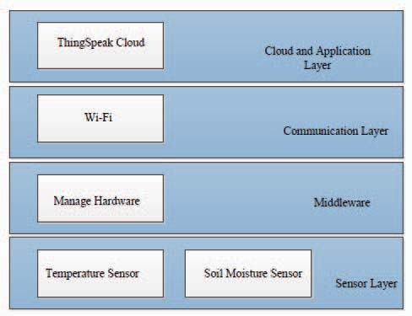

Fig. 1. Different layers of smart Farming System

1. *Sensor Layer*

This is the first layer of our proposed system. It is responsible for capturing and monitoring different environmental parameters. For sensing or collecting the parameters different kinds of sensors are deployed over the agriculture field. For this research work, two types of sensor have used: soil moisture sensor to monitor soil humidity level and temperature sensor to observe

## 626 2018 8th International Conference on Cloud Computing, Data Science & Engineering (Conﬂuence)

temperature level within poly houses. These sensors are attached with Arduino based microcontroller. The microcontroller attached with sensors formed basic IoT objects those are deployed over the agriculture field.

1. *Middleware design*

This is the second layer of our proposed system. The middleware is needed to automate the farming process and it controls the actuators. It is to be designed for microcontroller. Sensed values are fed into the microcontroller and depending upon the threshold values of different parameters of monitoring field it acts accordingly. This layer carefully monitors temperature and soil moisture level as these two parameters directly affects the crop yield and following decisions are made.

* + If soil moisture level is less than the threshold value then microcontroller will turn on the pump machine for watering the field as inadequate moisture content in soil will decrease the crop production. The threshold value of soil moisture content is different for different types of soil [12]. The recommended threshold values of soil moisture content for different types of soil at which irrigation takes place are given in Table 1 according to [12]. Proposed system considers 15% soil moisture content as a threshold. Once the moisture level reaches the threshold, pump will automatically turn off and thus avoids unnecessary electric power consumption.
  + If temperature level is greater than the threshold value then microcontroller will open the flap of the polyhouse. Proposed system considers 40° C temperature as a threshold. Increase in temperature results in reduction in crop duration and affects the equilibrium between crops and pests. It also increases the crop respiration rates and decreases the efficiency of fertilisers.

Apart from controlling the actuators, microcontroller sends the sensed data to the ThingSpeak cloud from the field through a gateway.

1. *Communication Layer*

In this layer microcontroller communicates with the gateway wirelessly through Wi-Fi module as it gives advantage over Bluetooth. Bluetooth provides short range communication than Wi-Fi as gateway may be far away from the monitoring field. Ethernet based communication is avoided due to huge cabling.

Here, microcontroller is equipped with sensors deployed over monitoring field and sending the sensed soil moisture and temperature value to the cloud through a gateway. IP based protocol is running on the gateway. Microcontroller sends HTTP request to the ThingSpeak cloud for writing sensed value to the corresponding channel.

1. *Cloud & Application layer*

Cloud computing is an emerging technology and can be used effectively in smart farming. The proposed model uses the cloud computing platform for recording different agricultural field data. In this layer different channels are created, each corresponds to specific parameter field in the ThingSpeak cloud for storing field data (temperature, soil moisture). Microcontroller sends the sensed data to the respective channel periodically through communication protocol. These data (soil moisture value, temperature value) are plotted with respect to time and can be used for future analysis. Agricultural field status (temperature, soil moisture) can be monitored remotely in terms of graph in ThingSpeak web service. Applications can be created related to farming which is deployed in the cloud and can be used by farmers or researchers.

TABLE II. SOIL MOISTURE CONTENT FOR IRRIGATION IN DIFFERENT TYPES OF SOIL

|  |  |
| --- | --- |
| **Soil Texture** | **Soil Moisture Content (%)** |
| Sand | 7 |
| Loamy Sand | 12 |
| Sandy Loam | 15 |
| Silt Loam | 20 |
| Loam | 23 |
| Silty Clay Loam | 28 |
| Clay Loam | 27 |
| Sandy Clay Loam | 24 |
| Sandy Clay | 22 |
| Silty Clay | 30 |
| Clay | 31 |

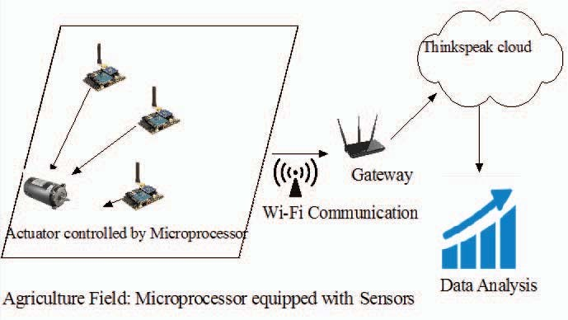

Fig. 2. System deployment model

1. EXPERIMENT AND RESULT

For realising the proposed system, different equipments are being used. Arduino UNO board is used as a microcontroller and different sensors are attached with it. LM35 was used as a temperature sensor and VL95 used as a soil moisture sensor. Steeper motor, fan are connected with Arduino UNO board through 6 pin relay to control high voltage device.

## 2018 8th International Conference on Cloud Computing, Data Science & Engineering (Conﬂuence) 627

LM35 is an integrated-circuit temperature device and it is connected to analog pin of Arduino board. Output of LM35 sensor is linearly proportional to the centigrade temperature and the measured value is fed into the middleware in the Arduino board. Fig. 3 shows the experimental setup of this work.

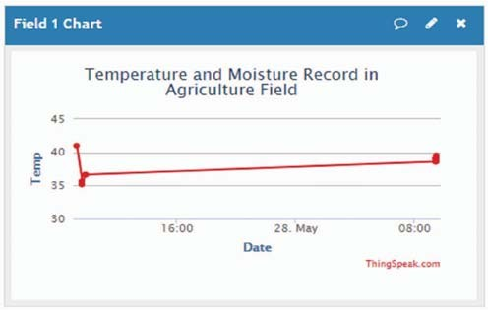

Fig. 4. Field Temperature with respect to time

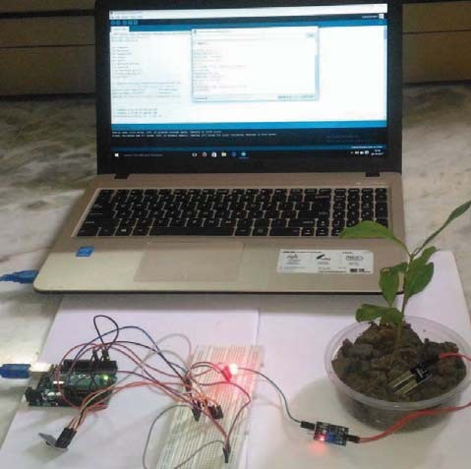

Fig. 3. Experimental Setup

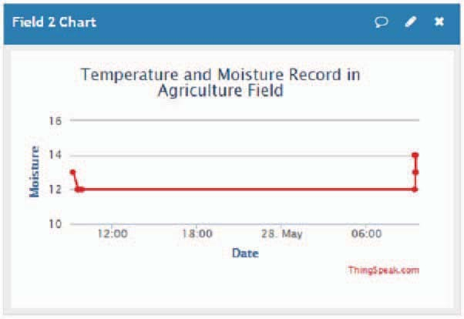

VL95 is moisture sensor and is connected to the analog pin of Arduino board and VL95 uses two probes to pass current through soil and reads resistance to get the soil moisture level. The measured values are fed into middleware in the Arduino board.

The sensed environmental values are fed to the middleware in the Arduino board and based on these values middleware controls the actuator (Controlling Pump, Fan). For designing middleware, Arduino IDE is used.

Apart from controlling actuators automatically, Arduino board send the measured parameters to the Cloud platform. Arduino board communicate with ThingSpeak cloud wirelessly through router for storing environmental parameters. Wi-Fi based communication is used in this model. ESP8266 module is used as a Wi-Fi module. ESP8266 module connects with specific gateway device having internet connectivity to communicate to the Cloud.

Based on the experimental setup, the proposed system has collected temperature and moisture of the soil from the monitoring field.

Then these sensed values are plotted in ThingSpeak web service deployed in cloud environment in every 15 seconds as ThingSpeak needs 15 seconds delay between updates. Fig. 4 shows field temperature value with respect to time.

On the other hand, Fig. 5 represents graph based on soil moisture level with respect to time.

Fig. 5. Soil Moisture level with respect to time

1. CONCLUSION

Based on above mentioned system setup, different level of soil moisture and temperature value were sensed and based on predefined threshold value of soil moisture and temperature, Arduino board controls the high voltage farming equipments without human intervention. In the absence of human being in the agriculture field, this system provides continuous field monitoring and triggers the appropriate events according to the requirement. It reduces the human effort and cost of farming to a certain extent.

For deploying the proposed system in different kind of soil texture environment mentioned in Table II, the threshold value of soil moisture and temperature needs to change and can be incorporated by manually updating the middleware.

Also the system sends the environmental parameters values to the cloud from the field in real time through wireless communication in every certain time interval. These values can be used for future analysis and can be considered for more parameters to be monitored like biotic factors such as fungi, monera etc. for better growth of the crop